
Instructor:
Mam Eman Basharat
Submitted By:
Abdul Bari
Registration Number:
2024-BS-CS-289
Department:
Computer Science
Course:
Database Systems
Course Code:
CS-213 Lab

Table of Contents
LAB 1: Introduction to SQL 3
LAB 2: Creating Tables 6
LAB 3: Inserting and Retrieving Data 9
LAB 4: Data Constraints in SQL 13
LAB 5: Data Retrieval Using ‘WHERE’ 20
LAB 6: Sorting and Filtering Data in SQL 26
LAB 7: Modifying Data and Aggregate Functions 31
LAB 8: Keys in DBMS 36
LAB 9: Filtering Data using ‘WHERE’ and ‘LIKE’ 41
LAB 10: Advanced Data Filtering I 47
LAB 11: Advanced Data Filtering II 52
LAB 12: Normalization 56
LAB 13: Inner and Cross Joins 61
LAB 14: Outer Join and It’s Types 63

LAB 1: Introduction to SQL
SQL (Structured Query Language) is the standard language used to interact with databases. It allows you to store, retrieve, update, and delete data in a relational database.
SQL is widely used in fields like data analysis, web development, backend systems, and business intelligence.

What is a Database?
A database is an organized collection of data. In SQL, data is stored in tables, which look like spreadsheets:
id | name | age
1 | Abdul Bari | 25
2 | Ali | 30
- Rows = records
- Columns = fields (attributes)

What Can SQL Do?
With SQL, you can:
- Query data (retrieve information)
- Insert new data
- Update existing data
- Delete data
- Create and modify tables and databases

Basic SQL Commands
1. SELECT (Retrieve Data)
SELECT name, age FROM users;
Gets specific columns from a table.
2. INSERT (Add Data)
INSERT INTO users (name, age)
VALUES ('Abdul Bari', 28);

3. UPDATE (Modify Data)
UPDATE users
SET age = 29
WHERE name = 'Abdul Bari';

4. DELETE (Remove Data)
DELETE FROM users
WHERE name = 'Abdul Bari';

5. CREATE TABLE
CREATE TABLE users (
id INT,
name VARCHAR(100),
age INT
);

Key Concepts
Primary Key:
A unique identifier for each row (e.g., id).
WHERE Clause:
Filters data:
SELECT * FROM users WHERE age > 25;

ORDER BY:
Sorts results:
SELECT * FROM users ORDER BY age DESC;

JOIN:
Combines data from multiple tables:
SELECT users.name, orders.product
FROM users
JOIN orders ON users.id = orders.user_id;

Types of SQL Databases
Some popular systems include:
- MySQL
- PostgreSQL
- SQLite
- Microsoft SQL Server
- Oracle Database

Why Learn SQL?
- Essential for working with data
- Used in almost every tech company
- Works with tools like Python, Excel, and BI platforms
- High demand skill in data-related jobs

LAB 2: Creating Tables

Creating Tables in MySQL
In MySQL, tables are created using the CREATE TABLE statement.

Basic Syntax
CREATE TABLE table_name (
column1 datatype constraints,
column2 datatype constraints,
column3 datatype constraints
);

Example: Create a Simple Table
CREATE TABLE students (
id INT PRIMARY KEY,
name VARCHAR(100),
age INT,
city VARCHAR(50)
);

Explanation
Column | Description
id | Integer value, unique for each student
PRIMARY KEY | Ensures each row is unique
VARCHAR(100) | Text up to 100 characters
age | Integer number
city | Stores city name

Common Data Types
Data Type | Purpose
INT | Whole numbers
VARCHAR(n) | Variable-length text
TEXT | Large text
DATE | Dates
FLOAT | Decimal numbers
BOOLEAN | True/False values

Using AUTO_INCREMENT
Automatically generates IDs:
CREATE TABLE employees (
emp_id INT AUTO_INCREMENT PRIMARY KEY,
emp_name VARCHAR(100),
salary FLOAT
);
When inserting data, you don't need to provide emp_id.

Adding Constraints
NOT NULL
Prevents empty values:
CREATE TABLE users (
id INT PRIMARY KEY,
username VARCHAR(50) NOT NULL
);

UNIQUE
Ensures no duplicate values:
email VARCHAR(100) UNIQUE

DEFAULT
Sets a default value:
status VARCHAR(20) DEFAULT 'active'

Complete Example
CREATE TABLE products (
product_id INT AUTO_INCREMENT PRIMARY KEY,
product_name VARCHAR(100) NOT NULL,
price FLOAT NOT NULL,
stock INT DEFAULT 0,
created_at DATE
);

Example Workflow
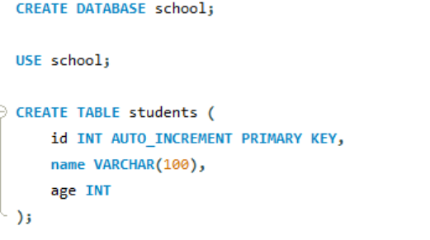

LAB 3: Inserting and Retrieving Data

Inserting and Retrieving Data in MySQL
Using MySQL, you can add data with INSERT and retrieve data with SELECT.

1. Inserting Data (INSERT INTO)
Basic Syntax
INSERT INTO table_name (column1, column2, column3)
VALUES (value1, value2, value3);

Example Table
CREATE TABLE students (
id INT AUTO_INCREMENT PRIMARY KEY,
name VARCHAR(100),
age INT,
city VARCHAR(50)
);

Insert One Row
INSERT INTO students (name, age, city)
VALUES ('Ali', 20, 'Faisalabad');
Since id is AUTO_INCREMENT, MySQL generates it automatically.
Insert Multiple Rows
INSERT INTO students (name, age, city)
VALUES
('Sara', 22, 'Lahore'),
('Ahmed', 21, 'Karachi'),
('Ayesha', 19, 'Islamabad');

2. Retrieving Data (SELECT)
Retrieve All Data
SELECT * FROM students;
* means all columns.
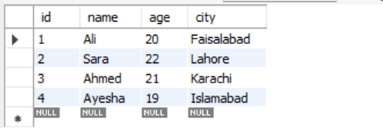
Retrieve Specific Columns
SELECT name, city FROM students;

Using WHERE (Filtering Data)
Students older than 20
SELECT * FROM students
WHERE age > 20;

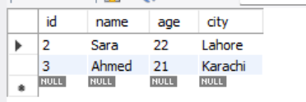

Find a specific student
SELECT * FROM students
WHERE name = 'Ali';

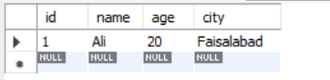

Sorting Data (ORDER BY)
Ascending Order
SELECT * FROM students
ORDER BY age ASC;

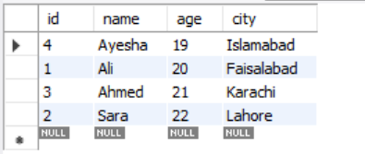

Descending Order
SELECT * FROM students
ORDER BY age DESC;

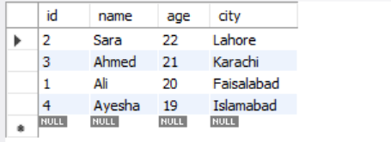

Limiting Results (LIMIT)
SELECT * FROM students
LIMIT 2;

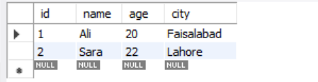
Returns only the first 2 rows.

Combining Conditions
SELECT * FROM students
WHERE age > 20 AND city = 'Lahore';

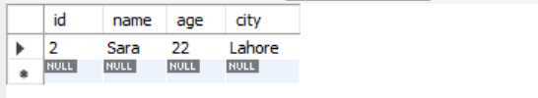

Full Example
CREATE DATABASE school;
USE school;
CREATE TABLE students (
id INT AUTO_INCREMENT PRIMARY KEY,
name VARCHAR(100),
age INT,
city VARCHAR(50)
);
INSERT INTO students (name, age, city)
VALUES
('Ali', 20, 'Faisalabad'),
('Sara', 22, 'Lahore');
SELECT * FROM students;

Example Output
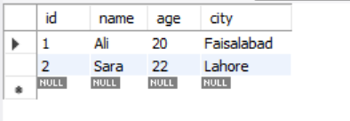

LAB 4: Data Constraints in SQL

Data Constraints in SQL
Constraints are rules applied to table columns to control what data can be stored. They help maintain data accuracy, consistency, and integrity.
In databases like MySQL and PostgreSQL, constraints are commonly used when creating tables.

Why Constraints Are Important
Constraints help:
- Prevent invalid data
- Avoid duplicate records
- Maintain relationships between tables
- Ensure required fields are filled

Common SQL Constraints
Constraint | Purpose
NOT NULL | Prevents empty values
UNIQUE | Prevents duplicate values
PRIMARY KEY | Unique identifier for each row
FOREIGN KEY | Links tables together
DEFAULT | Sets a default value
CHECK | Restricts allowed values
AUTO_INCREMENT | Automatically generates numbers

1. NOT NULL Constraint
Ensures a column cannot contain NULL.
CREATE TABLE students (
id INT,
name VARCHAR(100) NOT NULL
);
Trying to insert an empty name will cause an error.
2. UNIQUE Constraint
Ensures all values in a column are different.
CREATE TABLE users (
id INT,
email VARCHAR(100) UNIQUE
);
Duplicate emails are not allowed.
3. PRIMARY KEY Constraint
A combination of:
- NOT NULL
- UNIQUE
Each table should usually have one primary key.
CREATE TABLE employees (
emp_id INT PRIMARY KEY,
emp_name VARCHAR(100)
);

AUTO_INCREMENT with PRIMARY KEY
In MySQL:
CREATE TABLE employees (
emp_id INT AUTO_INCREMENT PRIMARY KEY,
emp_name VARCHAR(100)
);
IDs increase automatically.
4. DEFAULT Constraint
Provides a default value if none is supplied.
CREATE TABLE products (
product_id INT PRIMARY KEY,
stock INT DEFAULT 0
);
If stock isn't entered, it becomes 0.
5. CHECK Constraint
Restricts allowed values.
CREATE TABLE students (
id INT PRIMARY KEY,
age INT CHECK (age >= 18)
);
Only ages 18 or higher are allowed.
6. FOREIGN KEY Constraint
Creates a relationship between two tables.
Parent Table
CREATE TABLE departments (
dept_id INT PRIMARY KEY,
dept_name VARCHAR(100)
);

Child Table
CREATE TABLE employees (
emp_id INT PRIMARY KEY,
emp_name VARCHAR(100),
dept_id INT,
FOREIGN KEY (dept_id)
REFERENCES departments(dept_id)
);
dept_id in employees must exist in departments.
Combining Constraints
CREATE TABLE users (
id INT AUTO_INCREMENT PRIMARY KEY,
username VARCHAR(50) NOT NULL UNIQUE,
age INT CHECK (age >= 18),
status VARCHAR(20) DEFAULT 'active'
);

Adding Constraints Later
Add UNIQUE constraint
ALTER TABLE users
ADD UNIQUE (email);

Add FOREIGN KEY
ALTER TABLE employees
ADD FOREIGN KEY (dept_id)
REFERENCES departments(dept_id);

Removing Constraints
Drop UNIQUE constraint (MySQL)
ALTER TABLE users
DROP INDEX email;

Summary Table
Constraint | Example
NOT NULL | name VARCHAR(50) NOT NULL
UNIQUE | email VARCHAR(100) UNIQUE
PRIMARY KEY | id INT PRIMARY KEY
DEFAULT | status DEFAULT 'active'
CHECK | CHECK(age >= 18)
FOREIGN KEY | REFERENCES departments(id)

Best Practices
- Always use a PRIMARY KEY
- Use NOT NULL for required fields
- Use FOREIGN KEY to maintain relationships
- Use CHECK to validate input
- Use UNIQUE for emails/usernames

Example:
CREATE DATABASE company_db;

USE company_db;

CREATE TABLE departments (
dept_id INT AUTO_INCREMENT PRIMARY KEY,
dept_name VARCHAR(100) NOT NULL UNIQUE
);
CREATE TABLE employees (
emp_id INT AUTO_INCREMENT PRIMARY KEY,
emp_name VARCHAR(100) NOT NULL
email VARCHAR(100) UNIQUE
age INT CHECK (age >= 18)
salary FLOAT DEFAULT 30000,
dept_id INT,
FOREIGN KEY (dept_id)
REFERENCES departments(dept_id)
);
-- Insert data into departments table
INSERT INTO departments (dept_name)
VALUES
('HR'),
('IT'),
('Finance');
-- Insert data into employees table
INSERT INTO employees (emp_name, email, age, salary, dept_id)
VALUES
('Ali', 'ali@gmail.com', 25, 50000, 1),
('Sara', 'sara@gmail.com', 30, 70000, 2),
('Ahmed', 'ahmed@gmail.com', 22, DEFAULT, 3);

Output:
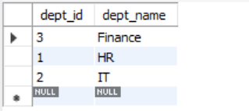

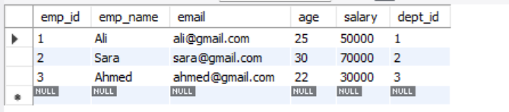

LAB 5: Data Retrieval Using ‘WHERE’

Data Retrieval Using WHERE in SQL
The WHERE clause is used to filter records based on conditions in MySQL.

Syntax
SELECT column_name
FROM table_name
WHERE condition;

Examples Using employees Table
Retrieve All Employees
SELECT * FROM employees;

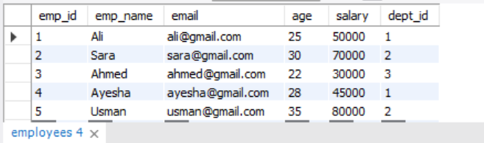

1. Retrieve Employees with Salary Greater Than 40000
SELECT * FROM employees
WHERE salary > 40000;

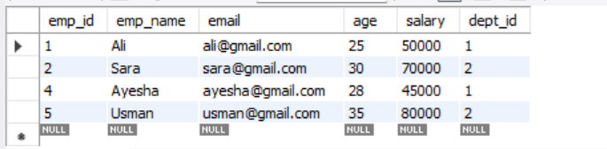

2. Retrieve Employee Named 'Ali'
SELECT * FROM employees
WHERE emp_name = 'Ali';

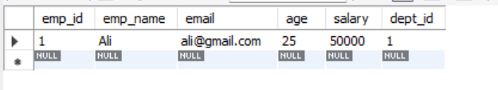

3. Retrieve Employees Older Than 24
SELECT * FROM employees
WHERE age > 24;

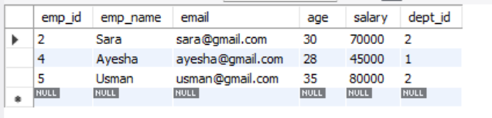

4. Retrieve Employees from Department 2
SELECT * FROM employees
WHERE dept_id = 2;

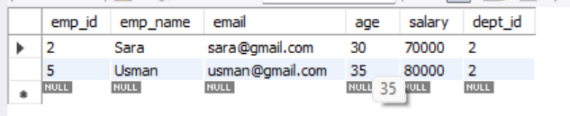

5. Using AND Operator
SELECT * FROM employees
WHERE salary > 40000
AND age > 25;

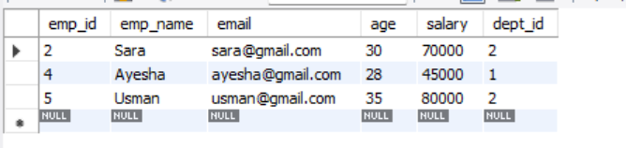

6. Using OR Operator
SELECT * FROM employees
WHERE dept_id = 1
OR dept_id = 2;

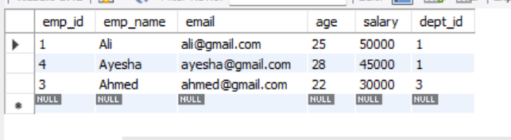

7. Using NOT Operator
SELECT * FROM employees
WHERE NOT dept_id = 3;

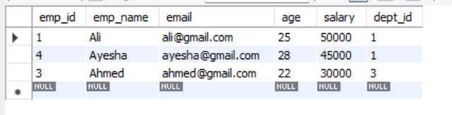

8. Using LIKE (Search Pattern)
Names starting with 'A'
SELECT * FROM employees
WHERE emp_name LIKE 'A%';

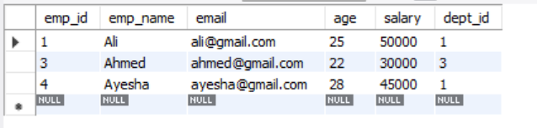

9. Using BETWEEN
SELECT * FROM employees
WHERE salary BETWEEN 30000 AND 60000;

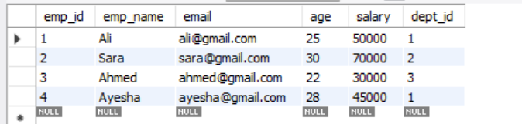

10. Using IN
SELECT * FROM employees
WHERE dept_id IN (1, 3);

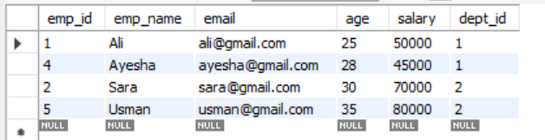

11. Using IS NULL
SELECT * FROM employees
WHERE email IS NULL;

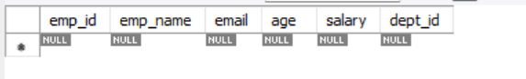

Combined Example
SELECT emp_name, salary
FROM employees
WHERE salary > 30000
AND age >= 25;

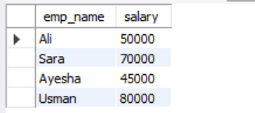

Common Comparison Operators
Operator | Meaning
= | Equal
!= or <> | Not equal
> | Greater than
< | Less than
>= | Greater or equal
<= | Less or equal

LAB 6: Sorting and Filtering Data in SQL

Examples Using employees Table
Retrieve All Employees
SELECT * FROM employees;



1. Retrieve Employees with Salary Greater Than 40000
SELECT * FROM employees
WHERE salary > 40000;



2. Retrieve Employee Named 'Ali'
SELECT * FROM employees
WHERE emp_name = 'Ali';



3. Retrieve Employees Older Than 24
SELECT * FROM employees
WHERE age > 24;



4. Retrieve Employees from Department 2
SELECT * FROM employees
WHERE dept_id = 2;



5. Using AND Operator
SELECT * FROM employees
WHERE salary > 40000
AND age > 25;



6. Using OR Operator
SELECT * FROM employees
WHERE dept_id = 1
OR dept_id = 2;



7. Using NOT Operator
SELECT * FROM employees
WHERE NOT dept_id = 3;



8. Using LIKE (Search Pattern)
Names starting with 'A'
SELECT * FROM employees
WHERE emp_name LIKE 'A%';



9. Using BETWEEN
SELECT * FROM employees
WHERE salary BETWEEN 30000 AND 60000;



10. Using IN
SELECT * FROM employees
WHERE dept_id IN (1, 3);



11. Using IS NULL
SELECT * FROM employees
WHERE email IS NULL;



Combined Example
SELECT emp_name, salary
FROM employees
WHERE salary > 40000
ORDER BY salary DESC;
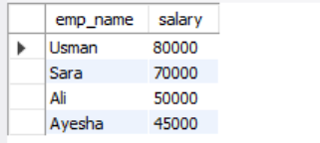

Operator | Meaning
= | Equal
!= | Not equal
> | Greater than
< | Less than
>= | Greater or equal
<= | Less or equal
BETWEEN | Range
LIKE | Pattern search
IN | Match multiple values

LAB 7: Modifying Data and Aggregate Functions

Modifying Data and Aggregate Functions in SQL
In MySQL, you use UPDATE, DELETE to modify data and aggregate functions to summarize data.

1. Modifying Data
A. UPDATE (Change Existing Data)
Syntax
UPDATE table_name
SET column1 = value1, column2 = value2
WHERE condition;

Example: Update Salary
UPDATE employees
SET salary = 60000
WHERE emp_name = 'Ali';

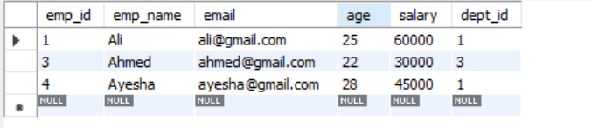

B. DELETE (Remove Data)
Syntax
DELETE FROM table_name
WHERE condition;

Example: Delete a Record
DELETE FROM employees
WHERE emp_name = 'Sara';

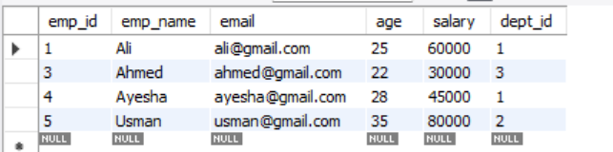

Delete All Rows (Be Careful)
DELETE FROM employees;

2. Aggregate Functions
Aggregate functions perform calculations on multiple rows and return a single result.
A. COUNT()
Counts rows.
SELECT COUNT(*) AS total_employees
FROM employees;

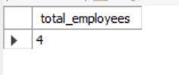

B. SUM()
Adds values.
SELECT SUM(salary) AS total_salary
FROM employees;



C. AVG()
Finds average value.
SELECT AVG(salary) AS average_salary
FROM employees;



D. MAX()
Finds highest value.
SELECT MAX(salary) AS highest_salary
FROM employees;



E. MIN()
Finds lowest value.
SELECT MIN(salary) AS lowest_salary
FROM employees;

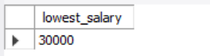

3. Aggregate Functions with GROUP BY
Example: Salary per Department
SELECT dept_id, SUM(salary) AS total_salary
FROM employees
GROUP BY dept_id;

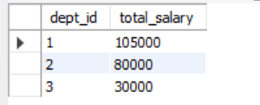

Example: Count Employees per Department
SELECT dept_id, COUNT(*) AS total_employees
FROM employees
GROUP BY dept_id;

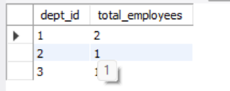

4. HAVING Clause (Filter Groups)
Used with aggregates (not individual rows).
SELECT dept_id, AVG(salary) AS avg_salary
FROM employees
GROUP BY dept_id
HAVING AVG(salary) > 50000;

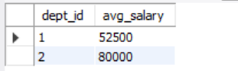

Summary
Modifying Data
- UPDATE → change data
- DELETE → remove data
Aggregate Functions
- COUNT() → number of rows
- SUM() → total
- AVG() → average
- MAX() → highest value
- MIN() → lowest value

LAB 8: Keys in DBMS

Keys in DBMS (Database Management System)
In a database, keys are used to uniquely identify records and establish relationships between tables. They are essential for maintaining data integrity in systems like MySQL.
1. Super Key
A super key is any set of columns that can uniquely identify a row.
Super keys:
- emp_id
- email
- {emp_id, name}
- {email, name}
Any combination that uniquely identifies a record.
2. Candidate Key
A candidate key is a minimal super key (no extra columns).
Example:
- emp_id
- email
Both can uniquely identify employees.
3. Primary Key
A primary key is the chosen candidate key used to uniquely identify rows.
Rules:
- Must be unique
- Cannot be NULL
- Only one per table
CREATE TABLE employees (
emp_id INT PRIMARY KEY,
email VARCHAR(100)
);

4. Alternate Key
Candidate keys not chosen as primary key.
Example:
- Primary Key = emp_id
- Alternate Key = email
5. Foreign Key
A foreign key creates a link between two tables.
CREATE TABLE departments (
dept_id INT PRIMARY KEY,
dept_name VARCHAR(100)
);

CREATE TABLE employees (
emp_id INT PRIMARY KEY,
dept_id INT,
FOREIGN KEY (dept_id) REFERENCES departments(dept_id)
);
Ensures valid relationships between tables.
6. Composite Key
A key made of two or more columns.
Example:
CREATE TABLE enrollment (
student_id INT,
course_id INT,
PRIMARY KEY (student_id, course_id)
);
Combination uniquely identifies each record.
7. Unique Key
Ensures all values are different (like primary key but allows NULL in some systems).
CREATE TABLE users (
id INT PRIMARY KEY,
email VARCHAR(100) UNIQUE
);

8. Surrogate Key
A system-generated key with no real meaning.
Example:
- Auto increment ID
emp_id INT AUTO_INCREMENT PRIMARY KEY

Summary Table
Key Type | Purpose
Super Key | Any unique identifier set
Candidate Key | Minimal unique key
Primary Key | Main unique identifier
Alternate Key | Other candidate keys
Foreign Key | Links tables
Composite Key | Multiple columns as key
Unique Key | Ensures uniqueness
Surrogate Key | System-generated ID

Quick Example (All Keys Together)
CREATE TABLE departments (
dept_id INT PRIMARY KEY,
dept_name VARCHAR(100) UNIQUE
);

CREATE TABLE employees (
emp_id INT AUTO_INCREMENT PRIMARY KEY,
email VARCHAR(100) UNIQUE,
name VARCHAR(100) NOT NULL,
dept_id INT,

FOREIGN KEY (dept_id) REFERENCES departments(dept_id)
);

Select:
SELECT
employees.name,
employees.email,
departments.dept_name
FROM employees
JOIN departments
ON employees.dept_id = departments.dept_id;

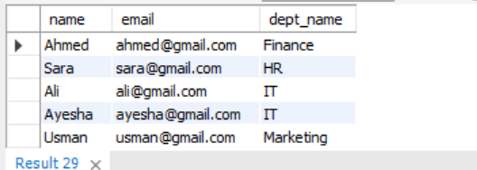

LAB 9: Filtering Data using ‘WHERE’ and ‘LIKE’

1. Filtering with WHERE
WHERE is used to filter rows based on conditions.
Basic Syntax

SELECT column_name
FROM table_name
WHERE condition;

Examples (Using employees table)

1. Employees in IT department
SELECT * FROM employees
WHERE dept_id = 2;

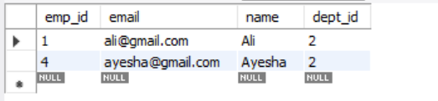

2. Employees with salary greater than 40000
SELECT * FROM employees
WHERE salary > 40000;

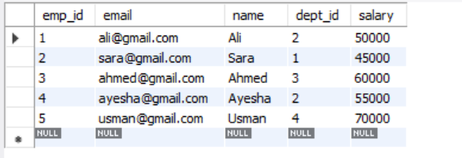

3. Employee named Ali
SELECT * FROM employees
WHERE name = 'Ali';

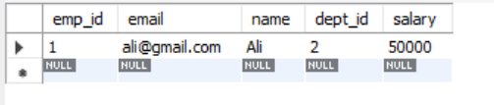

4. Multiple conditions (AND)
SELECT * FROM employees
WHERE dept_id = 2 AND salary > 30000;
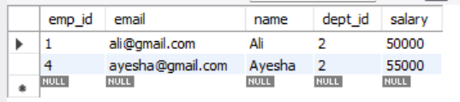

5. Multiple conditions (OR)
SELECT * FROM employees
WHERE dept_id = 1 OR dept_id = 3;

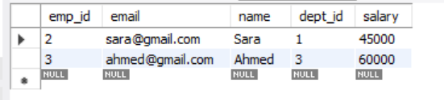

2. Filtering with LIKE
LIKE is used for pattern matching in text.
Wildcards
Symbol | Meaning
% | Any number of characters
_ | Single character

Examples
1. Names starting with 'A'
SELECT * FROM employees
WHERE name LIKE 'A%';

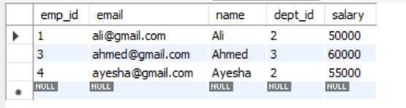

2. Names ending with 'a'
SELECT * FROM employees
WHERE name LIKE '%a';

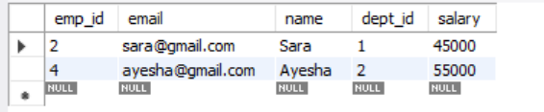

3. Names containing 'a'
SELECT * FROM employees
WHERE name LIKE '%a%';

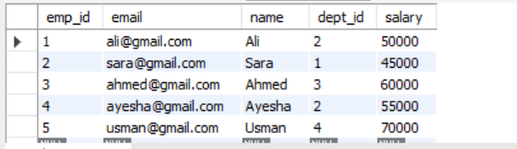

4. Names with exactly 4 letters
SELECT * FROM employees
WHERE name LIKE '____';

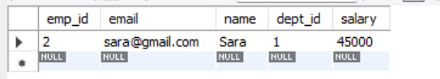

5. Names starting with 'S' and 3 more letters
SELECT * FROM employees
WHERE name LIKE 'S___';

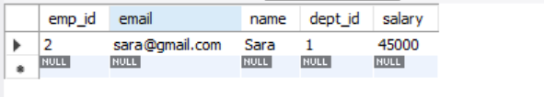

6. Emails from Gmail
SELECT * FROM employees
WHERE email LIKE '%@gmail.com';

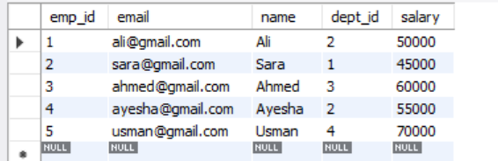

7. Exclude names starting with A
SELECT * FROM employees
WHERE name NOT LIKE 'A%';

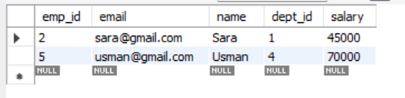

3. Combining WHERE + LIKE
Employees in IT whose name starts with A
SELECT * FROM employees
WHERE dept_id = 2
AND name LIKE 'A%';

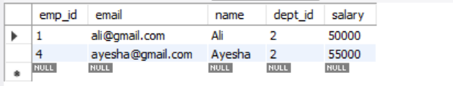

Employees earning more than 30000 and name contains 'a'

SELECT * FROM employees
WHERE salary > 30000
AND name LIKE '%a%';

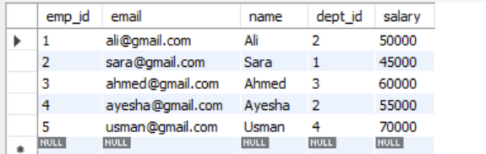

Summary
WHERE
- Filters rows using conditions
- Works with numbers, text, and dates
LIKE
- Used for pattern matching
- % = many characters
- _ = single character

LAB 10: Advanced Data Filtering I

1. ORDER BY (Sorting Data)
Used to sort results in ascending or descending order.
Syntax
SELECT * FROM employees
ORDER BY column_name ASC|DESC;

Examples

Sort by salary (low to high)
SELECT * FROM employees
ORDER BY salary ASC;

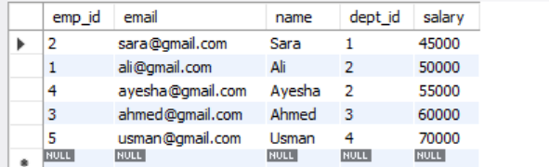

Sort by salary (high to low)
SELECT * FROM employees
ORDER BY salary DESC;

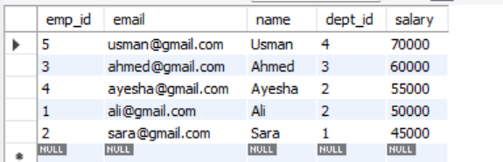

Sort by name alphabetically
SELECT * FROM employees
ORDER BY name ASC;

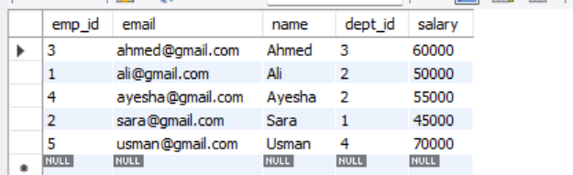

2. IN (Multiple Values Filter)
Used instead of many OR conditions.
Syntax
SELECT * FROM employees
WHERE column_name IN (value1, value2, value3);

Examples

Employees in dept 1, 2, or 3
SELECT * FROM employees
WHERE dept_id IN (1, 2, 3);

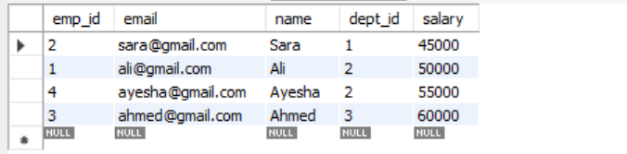

Employees named Ali, Sara, or Ahmed
SELECT * FROM employees
WHERE name IN ('Ali', 'Sara', 'Ahmed');

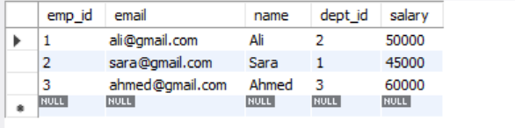

NOT IN (exclude departments)
SELECT * FROM employees
WHERE dept_id NOT IN (2);

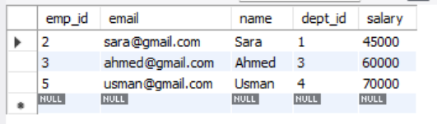

3. BETWEEN (Range Filtering)
Used for numeric or date ranges.
Syntax
SELECT * FROM employees
WHERE column_name BETWEEN value1 AND value2;

Examples

Employees with salary between 40000 and 60000
SELECT * FROM employees
WHERE salary BETWEEN 40000 AND 60000;

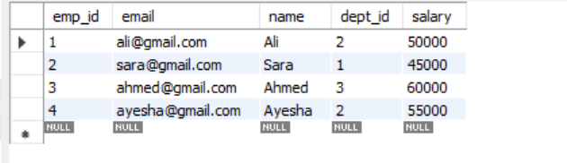

NOT BETWEEN (outside range)
SELECT * FROM employees
WHERE salary NOT BETWEEN 40000 AND 60000;

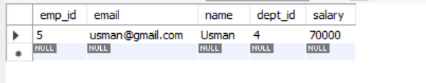

4. Combined Example (Very Important)
Filter + IN + ORDER BY
SELECT * FROM employees
WHERE dept_id IN (1, 2)
ORDER BY salary DESC;

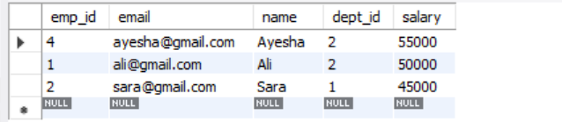

BETWEEN + ORDER BY
SELECT * FROM employees
WHERE salary BETWEEN 30000 AND 70000
ORDER BY salary ASC;

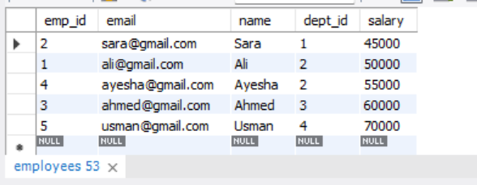

Quick Summary
Clause | Purpose
ORDER BY | Sort data
IN | Match multiple values
BETWEEN | Range filtering

LAB 11: Advanced Data Filtering II

1. Aggregate Functions
Aggregate functions perform calculations on multiple rows and return a single result.
A. COUNT()
Counts rows.
SELECT COUNT(*) AS total_employees
FROM employees;



B. SUM()
Adds values.
SELECT SUM(salary) AS total_salary
FROM employees;



C. AVG()
Finds average value.
SELECT AVG(salary) AS average_salary
FROM employees;



D. MAX()
Finds highest value.
SELECT MAX(salary) AS highest_salary
FROM employees;



E. MIN()
Finds lowest value.
SELECT MIN(salary) AS lowest_salary
FROM employees;



2. Aggregate Functions with GROUP BY
Example: Salary per Department
SELECT dept_id, SUM(salary) AS total_salary
FROM employees
GROUP BY dept_id;



Example: Count Employees per Department
SELECT dept_id, COUNT(*) AS total_employees
FROM employees
GROUP BY dept_id;



3. HAVING Clause (Filter Groups)
Used with aggregates (not individual rows).
SELECT dept_id, AVG(salary) AS avg_salary
FROM employees
GROUP BY dept_id
HAVING AVG(salary) > 50000;



Summary
Aggregate Functions
- COUNT() → number of rows
- SUM() → total
- AVG() → average
- MAX() → highest value
- MIN() → lowest value

LAB 12: Normalization

Normalization in DBMS
Normalization is the process of organizing data in a database to reduce redundancy (duplicate data) and improve data integrity.
It is used in relational databases like MySQL.

Why Normalization is Needed
Without normalization:
- Data is repeated (waste of space)
- Updates become difficult
- Insertion and deletion anomalies occur

Example of Bad (Unnormalized) Table
student_id | name | course | teacher
1 | Ali | SQL | Mr. Khan
2 | Ali | Python | Mr. Ahmed
3 | Sara | SQL | Mr. Khan
Problems:
- "Ali" repeats
- "SQL → Mr. Khan" repeats
- If teacher changes, multiple rows must be updated

1NF (First Normal Form)
Rule:
- Each column must have atomic (single) values
- No repeating groups
Already in 1NF:
student_id | name | course | teacher
No multiple values in one cell

2NF (Second Normal Form)
Rule:
- Must be in 1NF
- Remove partial dependency
Problem:
Teacher depends on course, not student.
Split into tables:

Students Table

student_id | name
1 | Ali
2 | Sara

Courses Table

course | teacher
SQL | Mr. Khan
Python | Mr. Ahmed
Enrollment Table

student_id | course
1 | SQL
1 | Python
2 | SQL

3NF (Third Normal Form)
Rule:
- Must be in 2NF
- Remove transitive dependency
Example:
If teacher depends on course, not directly on student → separate it.
Already fixed in above structure

Final Normalized Structure
Students
- student_id (PK)
- name
Courses
- course_id (PK)
- course_name
- teacher
Enrollment
- student_id (FK)
- course_id (FK)

Benefits of Normalization
- Removes duplicate data
- Saves storage
- Improves consistency
- Makes updates easier
- Reduces anomalies

Types of Anomalies Prevented
1. Insertion Anomaly
Cannot insert data without unnecessary fields
2. Update Anomaly
Same data must be updated in multiple places
3. Deletion Anomaly
Deleting one record removes useful information

Simple Real-Life Example
Instead of storing this:
“Ali → SQL → Mr. Khan” (repeated many times)
We store:
- Ali in Students table
- SQL in Courses table
- Relationship in Enrollment table

Summary
Normal Form | Goal
1NF | Atomic values
2NF | Remove partial dependency
3NF | Remove transitive dependency

LAB 13: Inner and Cross Joins

1. INNER JOIN
What it does
INNER JOIN returns only the matching rows between two tables based on a condition.
Syntax
SELECT columns
FROM table1
INNER JOIN table2
ON table1.column = table2.column;

Example (Employees + Departments)

SELECT
employees.name,
employees.email,
departments.dept_name
FROM employees
INNER JOIN departments
ON employees.dept_id = departments.dept_id;

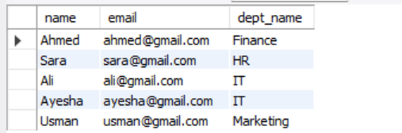

Key Point
- Only shows employees that have a valid department
- If no match → row is NOT shown

2. CROSS JOIN
What it does
CROSS JOIN returns the Cartesian product (all possible combinations of rows).
Syntax
SELECT *
FROM table1
CROSS JOIN table2;

Example
SELECT
employees.name,
departments.dept_name
FROM employees
CROSS JOIN departments;

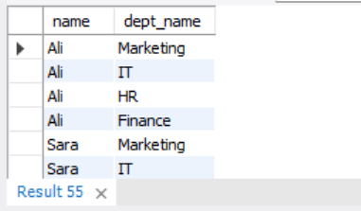
Key Point
- Every employee combines with every department
- No condition required

Difference Between INNER JOIN and CROSS JOIN
Feature | INNER JOIN | CROSS JOIN
Matching required | Yes | No
Output size | Smaller | Very large
Condition (ON) | Required | Not needed
Use case | Real relationships | Combinations

Quick Real-Life Meaning
INNER JOIN
“Show employees with their correct departments”
CROSS JOIN
“Show every employee with every department (all possibilities)”

Simple Summary
- INNER JOIN → matches only related data
- CROSS JOIN → all combinations of data

LAB 14: Outer Join and It’s Types

OUTER JOIN and Its Types in SQL
In MySQL, OUTER JOIN is used to return matching rows + non-matching rows from one or both tables.
It is mainly used to avoid losing data when matches don’t exist.
We use it with tables like:
- employees
- departments

1. LEFT OUTER JOIN (LEFT JOIN)
What it does
Returns:
- All rows from left table
- Matching rows from right table
- Non-matching rows → NULL
Syntax
SELECT columns
FROM table1
LEFT JOIN table2
ON table1.column = table2.column;

Example

SELECT
employees.name,
departments.dept_name
FROM employees
LEFT JOIN departments
ON employees.dept_id = departments.dept_id;

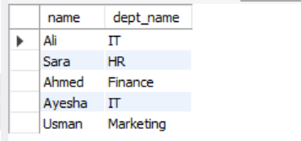

2. RIGHT OUTER JOIN (RIGHT JOIN)
What it does
Returns:
- All rows from right table
- Matching rows from left table
- Non-matching rows → NULL
Syntax
SELECT columns
FROM table1
RIGHT JOIN table2
ON table1.column = table2.column;

Example

SELECT
employees.name,
departments.dept_name
FROM employees
RIGHT JOIN departments
ON employees.dept_id = departments.dept_id;

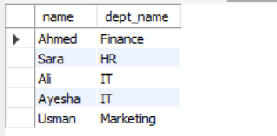

3. FULL OUTER JOIN (Concept)
What it does
Returns:
- All rows from both tables
- Matching + non-matching rows
Important Note
MySQL does NOT directly support FULL OUTER JOIN
But conceptually:
SELECT *
FROM employees
LEFT JOIN departments ON employees.dept_id = departments.dept_id

UNION

SELECT *
FROM employees
RIGHT JOIN departments ON employees.dept_id = departments.dept_id;

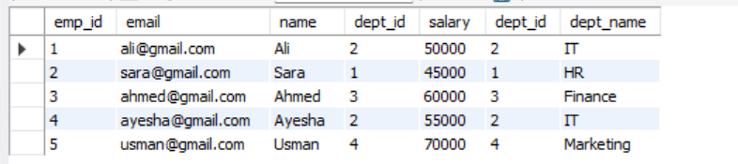

4. Quick Comparison
Type | Includes Left Table | Includes Right Table | Unmatched Data
LEFT JOIN | ✔ | ✖ | Left side
RIGHT JOIN | ✖ | ✔ | Right side
FULL OUTER JOIN | ✔ | ✔ | Both sides

5. Easy Real-Life Meaning
- LEFT JOIN → “Show all employees, even if no department”
- RIGHT JOIN → “Show all departments, even if no employees”
- FULL JOIN → “Show everything from both sides”

Summary
- OUTER JOIN = includes unmatched rows
- LEFT JOIN = left table is priority
- RIGHT JOIN = right table is priority
- FULL JOIN = both tables fully combined

